#### HUMAN BIOLOGICAL SCIENCES STAGE 2

## **MID-SEMESTER TEST 1**

Part I: Multiple Choice 15 marks

Part III: Short Answer 35 marks

Part II: Extended Answer 10 marks

Total 60 marks

Name: _____________________________

**PART I: MULTIPLE CHOICE [15 marks]**

SELECT THE SINGLE CORRECT ALTERNATIVE IN EACH OF THE FOLLOWING QUESTIONS

___________________________________________________________________

1. The correct function of pepsin is to
2. Coagulate milk proteins
3. Protect the lining of the stomach from gastric enzymes
4. Digest RNA and DNA
5. Split proteins into polypeptides and amino acids
6. The heart pictured below has been sliced through the plane AB. A view looking through this plane is shown on the right. Blood filled regions are indicated by X and Y.

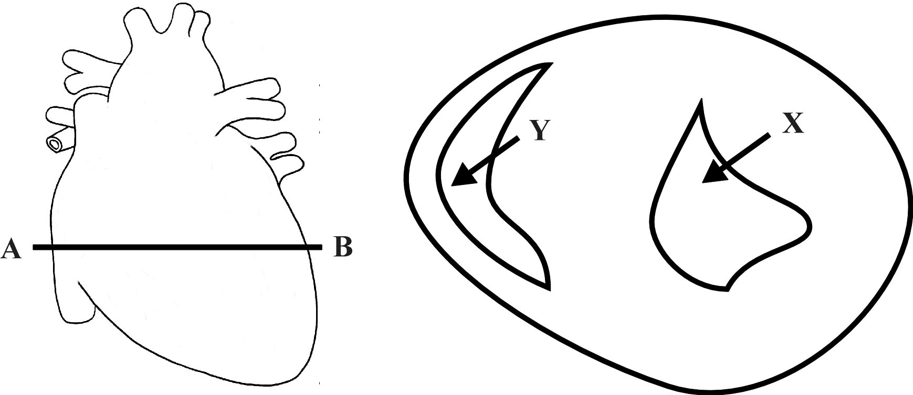

Which of the following four statements about X and Y is not correct?

1. The blood in Y would leave the heart via the pulmonary vein.
2. The blood in X has come directly from the left atrium.
3. The blood in X has a higher concentration of oxyhaemoglobin than the blood in Y.
4. The blood would flow from X into the aorta.
5. Which of the following statements about the transport of respiratory gases is incorrect?
6. Most O2 is transported in combination with haemoglobin.
7. Most CO2 is transported in red blood cells.
8. Some O2 is dissolved in the plasma.
9. Some CO2 is combined with haemoglobin.
10. If a molecule of carbon dioxide was released into the blood at your left foot and then travelled directly to your lungs and out through your nose, it would pass through all of the following structures except one. Which one?
11. Inferior vena cava
12. Pulmonary vein
13. Femoral vein
14. Right ventricle
15. If the percentage of oxygen in inspired air was raised to 25%, which of the following would occur?
16. The rate of diffusion of oxygen from alveoli to capillaries would increase
17. There would be a significant increase in the amount of oxyhaemoglobin formed in red blood cells
18. The rate of diffusion of oxygen from the capillaries to the alveoli would increase
19. The rate and depth of breathing would increase
20. The diagram below represents a cell in fluid. Formulas for the molecules that can move freely across the cell membrane are shown. Some molecules are located inside the cell and other are in the fluid outside the cell.

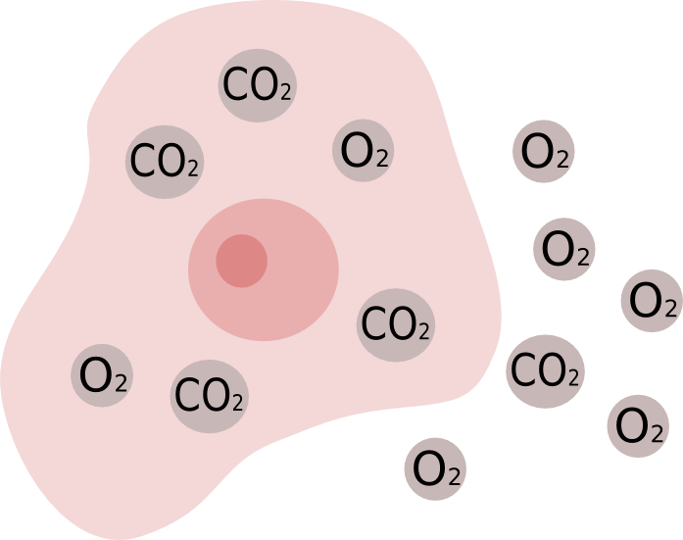

Based on the distribution of these molecules, what would most likely happen after a period of time?

1. The concentration of O2 will increase inside the cell.
2. The concentration of CO2 will remain the same inside the cell.
3. The concentration of O2 will remain the same outside the cell.
4. The concentration of CO2 will decrease outside the cell.
5. As a large carbohydrate molecule is digested it would pass through all of the following organs, except one. Through which organ would it not pass?
6. Oesophagus
7. Stomach
8. Pancreas
9. Small intestine
10. In humans, oxygen is carried around the body in chemical combination with a molecule called haemoglobin. This iron based chemical compound has a great capacity to carry oxygen. In humans it increases the blood’s oxygen carrying capacity 65-70 times above that normally dissolved in plasma. The chemical reaction for haemoglobin combining with oxygen is shown below:

Hb + O2 ⇒ HbO2 (in the lungs)

HbO2 ⇒ Hb + O2 (in the body tissues)

Note: Hb = haemoglobin, HbO2 = oxyhaemoglobin

The physical factor that determines how much oxyhaemoglobin is produced is the partial pressure of oxygen. The relationship between these two variables is shown in the graph below.

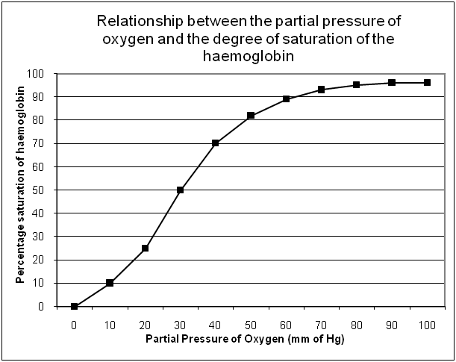

**I**

**II**

**III**

Which point (or points) on the graph best represents the haemoglobin in the lungs?

1. I only
2. II only
3. III only
4. I and II only
5. Below are four lists of molecules. Which list best represents the end products of the process of digestion?
6. Glucose, amino acids, triglycerides
7. Monosaccharides, amino acids, fatty acids
8. Monosaccharides, polypeptides, fatty acids
9. Glycerol, amino acids, lipids
10. The main function of intestinal villi is to
    1. Rhythmically beat back and forth moving food along the intestine
    2. Surround and digest food particles
    3. Greatly increase the area over which absorption of food can occur
    4. Secrete enzymes to complete chemical digestion.
11. The main function of the colon in humans is to
    1. Absorb the products of digestion
    2. Digest cellulose
    3. Provide temporary storage for excretory matter (i.e. faeces)
    4. Absorb water from undigested food
12. Which of the following statements about bile is correct?
13. Bile is produced and stored in the liver
14. The gall bladder stores and concentrates bile
15. The pancreas synthesises bile and transports it to the duodenum via the common bile duct
16. Bile chemically breaks up large lipid molecules into smaller ones
17. The structures most directly involved in providing oxygen to and removing carbon dioxide from the cells are:
18. Veins and arteries
19. Trachea and lungs
20. Mouth and nose
21. Capillaries and alveoli
22. Which of the following lung diseases is characterised by infection and increased mucous production in the alveoli?
23. Emphysema
24. Lung Cancer
25. Pneumonia
26. Asthma
27. Diagrams, tables, and graphs are used by scientists mainly to
28. design a research plan for an experiment
29. organize data
30. test a hypothesis
31. predict the independent variable

PART II BEGINS ON THE NEXT PAGE

**PART II: SHORT ANSWERS [35 marks]**

Write answers to **ALL** questions on the ruled lines after each question or in the spaces provided within each table.

Question 1

Study the diagram below:

One complete cardiac cycle (0.8 seconds)

1. What happens during atrial systole? [1]
2. What is happening in the heart during the period of time shaded blue in the diagram? [1]
3. How long does atrial systole last? (Use the diagram above to calculate.) [1]
4. During which phase would blood pressure be at its highest? [1]

Question 2

1. Below is a diagram of the human heart. Write the correct name of the parts in the blank boxes [4]

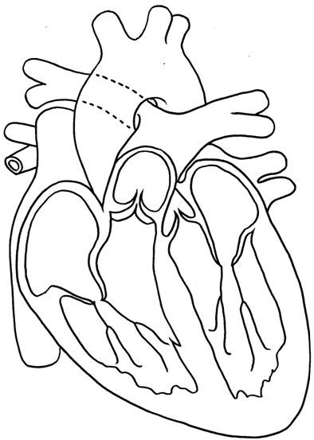

(Valve)

(Chamber)

1. What happens to the semilunar valves as the ventricles contract? [1]
2. Which part of an ECG trace indicates the contraction of the atria? [1]
3. What is the function of the SA node? [1]

Arteries and arterioles are able to adjust their diameter to alter blood flow to organs. This is normally controlled by nerves, but some substances can alter the diameter of blood vessels.

1. What effect does adrenaline have on the blood vessels of skeletal muscles and the heart? [1]

Question 3

1. Describe the link between poor diet, atherosclerosis and the risk of a heart attack. [3]
2. Cardiac output is equal to stroke volume multiplied by heart rate. Define the term ‘stroke volume’. [1]
3. As some people age, one or more heart valves may start to fail. If the bicuspid valve of heart begins to fail (leaks), what effect would this have on heart rate and stroke volume? [2]

Question 4

The mouth begins the digestive process.

1. Name and describe the importance of the mechanical digestion that occurs in the mouth. [2]
2. Describe the chemical digestion that occurs in the mouth. [2]
3. Explain why the digestive enzymes secreted in the mouth stop working when the bolus reaches the stomach. [2]

Question 5

The diagram below shows the organs of the digestive system.

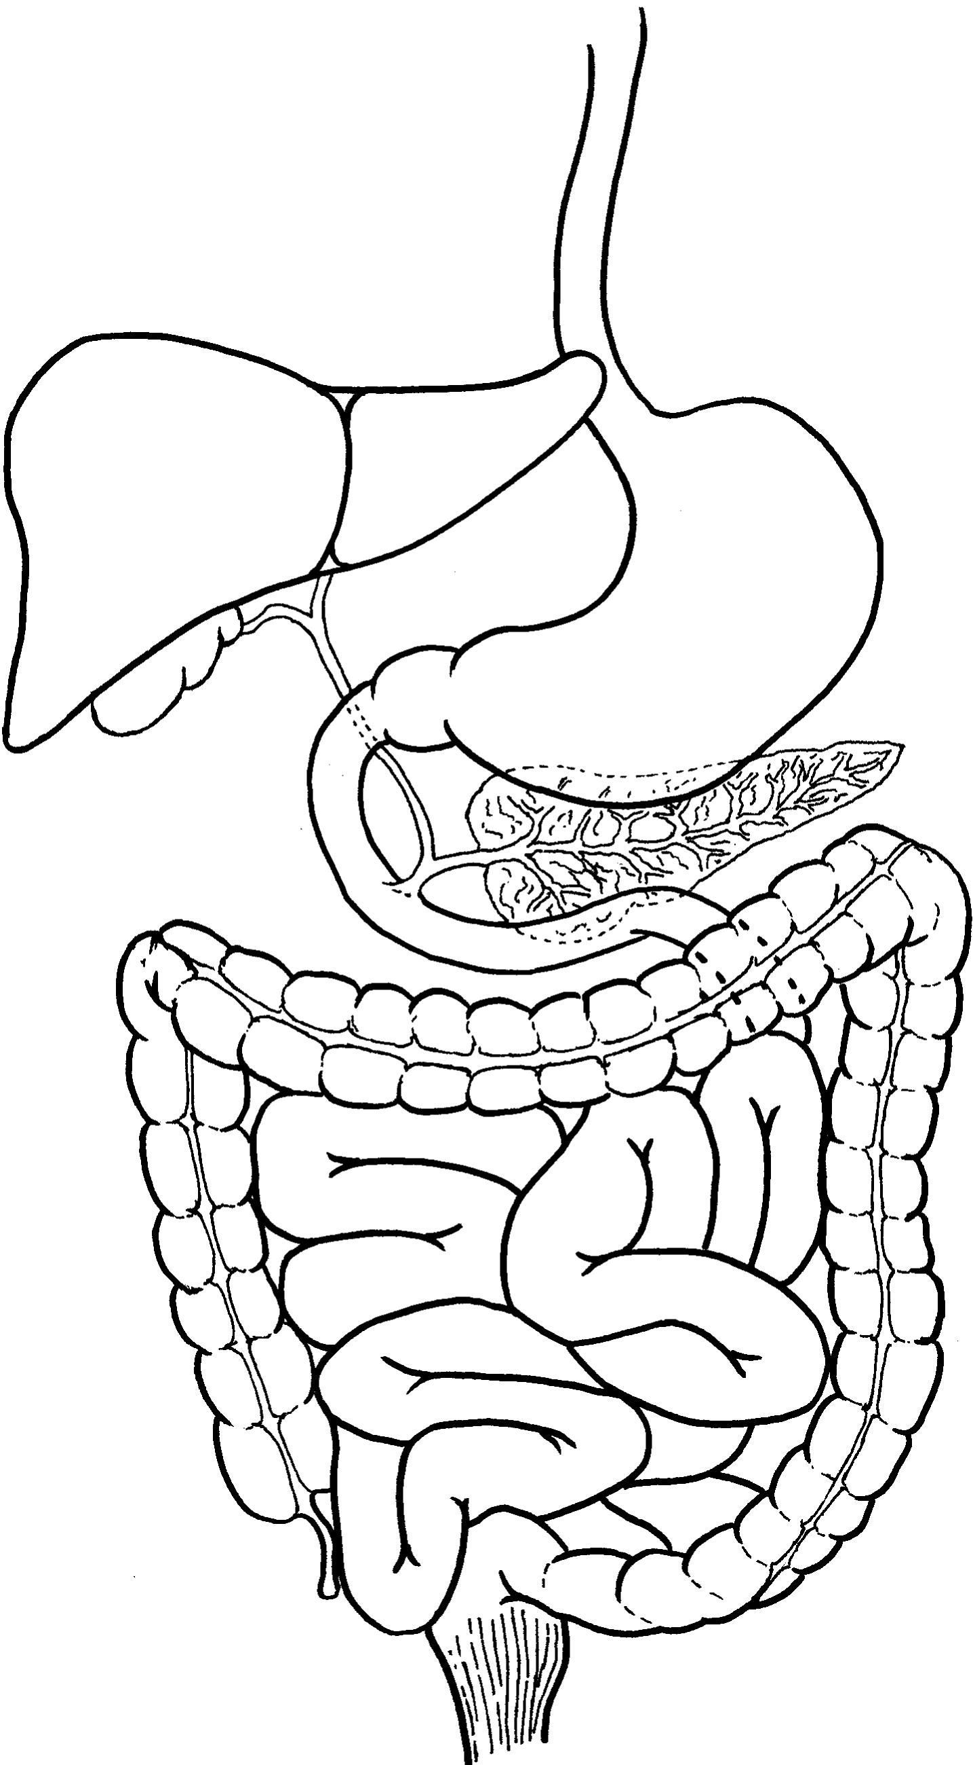

(i)

(ii)

(iii)

(iv)

(v)

(vi)

(a) Identify the following labelled structures:

(ii) ______________________ (v) _________________________

(iii) ______________________ (vi) _________________________

(2 marks)

Question 6

The diagram below shows the three main types of blood vessels (not to scale).

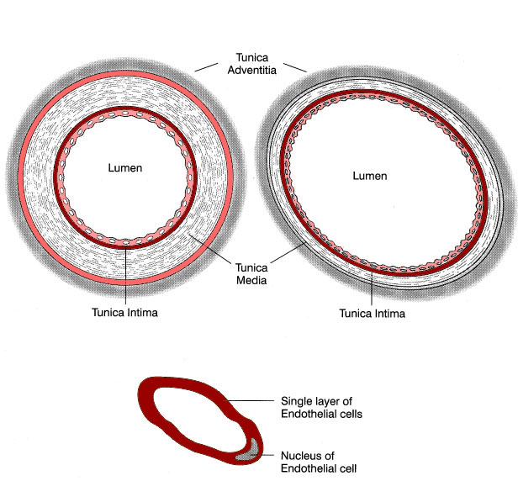

**Z**

**Y**

**X**

Complete the table by writing in the letter (of the blood vessel) that best matches the description in the left hand column. [2]

|  |  |
| --- | --- |
| Carries blood back to the heart |  |
| Has the most elastic fibres in the tunica media |  |
| Has the highest surface area to volume ratio |  |
| Best represents a coronary artery |  |

Question 7

Some people with asthma find that their condition is made worse when they are exposed to house dust mites. An experiment was conducted to investigate the relationship between dust mites and asthma. Eight people, aged 18-20, with mild asthma volunteered to have their peak expiratory flow rate (PEFR)* measured before and after exposure to dust mites. The figure below shows the results of this experiment.

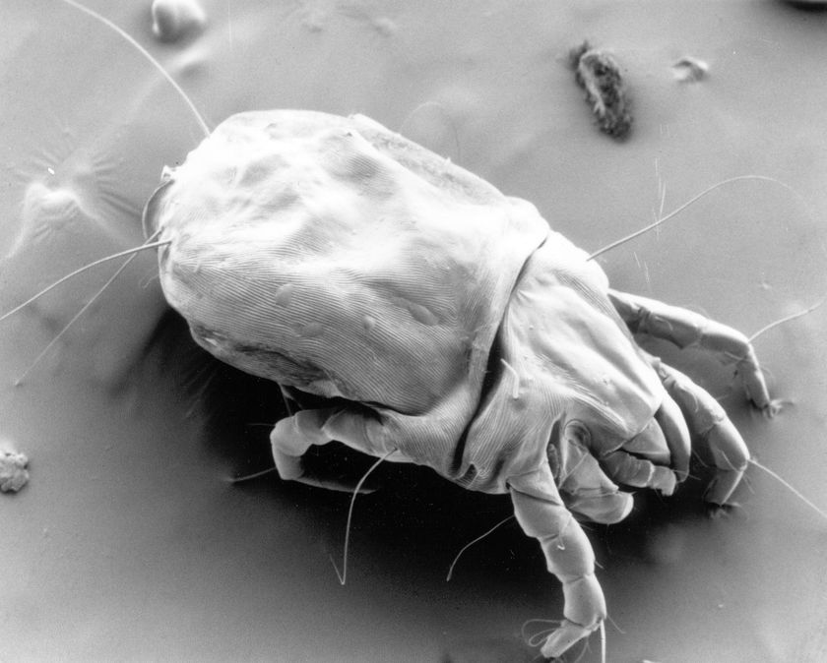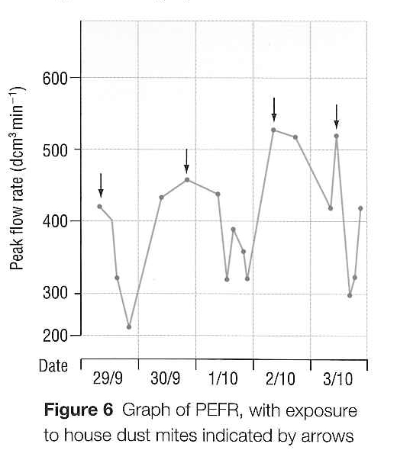

Dust mite photographed with a scanning electron microscope. (100x magnification)

* Peak expiratory flow rate (PEFR) is the maximum rate at which air can be forcibly breathed out through the mouth.

1. Does the graph support the hypothesis that asthma is made worse by exposure to dust mites? Explain your answer. [2]
2. Explain why PEFR is lower when a person is having an asthma attack. [2]
3. What is the independent variable in this experiment?
4. Other than age and severity of asthma, suggest two other variables that should have been controlled in this experiment. [1]
5. How could the reliability of this experiment be improved? [1]

PART III BEGINS ON THE NEXT PAGE

**PART III: EXTENDED ANSWERS [10 marks]**

Write your answers to thEsE questions on the lined paper on the following pages.

ANSWER BOTH QUESTIONS.

Question 1

Using labelled diagrams show the structural differences between the three cellular components of blood

[5]

Question 2

Describe five functions of blood.

[5]

END OF TEST